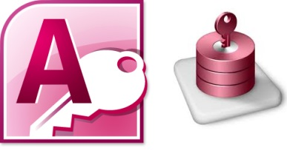 

Custom Ribbon Menu Tab

Requirements

1. **Tables (mnuTab, mnuGroup, mnuCommand)**
   * mnuTab – can change name of tab
     1. IMPORTANT: if name changes, then tab must be re-selected in Database Options (see #5 below)
   * mnuGroup – can add/delete tab groups OR change name and order of groups
   * mnuCommand – can customize individual items within tab groups including add/delete items OR change name, order, label, description, icon, icon size, and target pointing to objects in current database (forms, queries, macros)
     1. any changes to labels/description/icons reflect on re-open of database
     2. any changes to targets reflect immediately
     3. icons must align to same exact spelling in attached *Office2010IconsGallery* which populates all MS Office Suite icons
2. **Query (mnuCommands)**
   * Simple join of mnu tables used in custom UI XML creation (see GetRibbonDefinition() function in customRibbon module).
3. **Module (customRibbon)**
   * Two functions: GetRibbonDefinition(), LoadRibbon()
   * Two subroutines: GetImage, OnMenuAction
4. **VBA Reference (MS Office Library (14.0+))**
   * Select in VBE Window (Alt+F11) and on menu Tools \ References
   * Used to obtain graphics of menu tab icons (see attached Word document, *Office2010IconsGallery.docx*)
5. **Ribbon Selection under Options \ Current Database \ Ribbon & Toolbar Options**
   * Find custom ribbon name (specified in mnuTab table)
6. **AutoExec macro or opening form’s OnOpen trigger event calling function LoadRibbon() in customRibbon module**
   * IMPORTANT: ribbon must be called before any object of database opens to screen and can only be loaded once.